Cargilfield School
Guidelines to Staff for dealing with Child Mental Health Issues

- School responsibilities
  - The School has in place detailed Policy and Guidance on Child Protection developed in accordance with Getting it Right for Every Child: Children and Young Persons Act 2014 (“GIRFEC”).
  - At the heart of the GIRFEC approach is early, proactive intervention in order to create a supportive environment for each child and identify any additional support that may be required as soon as possible. GIRFEC places the needs of children and young people first, ensures that they are listened to and understand decisions which affect them and that they get coordinated help where this is required to support their well-being, health and development.
- Background
  - One in ten young people between the ages of 5 and 16 will have an identifiable mental health issue at any one time. Around 75% of mental health disorders are diagnosed in adolescence. Identifiable mental health issues which have affected children at Cargilfield include anxiety and depression, eating disorders and self-harm.
- Procedures
  - The most important role staff can play is to familiarise themselves with the procedures given below that are to be followed if they have a concern about a child, if another pupil raises a concern about one of their friends or if a child speaks to a member of staff about how they are feeling.
- Child’s Plan (CP)
  - The Headmaster may decide following consultation between the Signposters, School Counsellor (where appropriate) the child’s parents and other relevant parties to produce a CP. This will be made available to school staff to allow them to provide an appropriate level of support for the child. This will be produced in accordance with the GIRFEC guidelines (see the School’s Child Protection Policy for further guidance).
- Confidentiality and information sharing
  - Children may choose to confide in any member of school staff if they are concerned about their own welfare or that of a peer. Children must be made aware that it may not be possible for staff to offer confidentiality. If a member of staff considers that a child is at serious risk of causing harm to themselves then confidentiality cannot be kept.
  - Parents must disclose to the school any known mental health issue or concerns that they have about their child’s mental health or emotional wellbeing. This includes any change in family circumstance that may impact on a child’s emotional wellbeing.

- The School Counsellor and Signposters
  - The School has a school counsellor who comes into school one day every week and supports children with a whole range of issues. They will not see a child until this has first been agreed with the parent or carer or in case of emergency sanctioned by the Headmaster.
  - The Headmaster may recommend that an appointment is made with the School Counsellor. In most cases he will have the prior agreement of the parents to do this and they will be charged accordingly for the appointment.
  - If the child concerned is in receipt of a bursary or other funding for the School and the Headmaster in his discretion believes that the child’s parents are not in a position to pay for counselling then he may agree to arrange an appointment with the School Counsellor at the School’s expense. The Headmaster will consider this on a case by case basis.
  - The child’s parents may advise the Headmaster that they intend to seek the services of another counsellor or appropriate professional. In the event that this does not happen within a reasonable amount of time (as determined by the Headmaster) then the Headmaster reserves the right to exclude the child from school in accordance with paragraph 11.b below.
  - The Headmaster may also ask the School Counsellor to assist with staff training. The cost of this will fall to the school.
- Notification
  - As a general rule the School will apply the same procedures with regard to informing parents of concerns about a child’s mental health as it already does with issues of a physical nature such as a fall or accident at school.
  - In a situation which the Signposter believes to be of high risk they will inform the Headmaster (or in his absence EB) as soon as possible.
  - The Headmaster (or in his absence a Signposter) will use his best endeavours to speak to parents as soon as possible.
  - A qualified mental health first aider (or Signposter) will usually be available during the school day.

- Mental Health First Aid
  - In order to ensure adequate mental health first aid provision, we endeavour to have sufficient numbers of trained staff to support those children who are experiencing mental or emotional difficulties.

- Responsibilities
  - The School Nurse is responsible for maintaining accurate records of all mental health first aid given in school.
  - Qualified child mental health first aiders are responsible for
    - Responding promptly to calls for assistance
    - Providing first aid support within their level of competence
    - Summoning medical health as necessary (after consultation with the School Nurse and the Headmaster).
  - All staff are reminded that
    - A record of all incidents should be kept in line with the usual school procedures for reporting incidents. These are filed on the accident and incidents file in the staff drive and are available for all staff to see.
    - Welfare concerns should be raised with the Deputy Head (Child Protection) who is Emma Buchanan, using the school’s Welfare Concern Form using the Welfare Indicators in the GIRFEC national practice model. There may be limited access to these records. Should you have a specific concern in relation to a welfare (or Child Protection) concern please speak to EB and she will provide you with advice.
    - Child Protection concerns should be raised immediately with the Deputy Head (Child Protection) or in her absence the Deputy CPO who is Sian Mackenzie.
    - We are working towards recording incident and welfare concerns on the school’s management information system. Once this is fully implemented staff (dependent on their level of access) will be able to find this information linked to individual children.
- Qualified Mental Health First Aiders (Signposters)
  - These are staff who have undertaken a training course (Scotland’s Mental Health: Young People) developed by NHS Scotland and hold a valid certificate of competence. This does not prepare staff to become therapists. It does however, enable them to recognise the symptoms of mental ill health and how to provide initial help and guide a child towards appropriate professional help.
  - All staff have a duty of care towards the children in the School and should respond accordingly when first aid situations arise. All staff are reminded regularly through the weekly minutes of the Pastoral Committee or the weekly Pre Prep staff meeting about the specific needs of the children and they are asked to familiarise themselves with individual Child Plans (CP).
- Absence from school
  - If a child is absent from school for any length of time the Headmaster will discuss with the parents appropriate arrangements to send work home. This will be in consultation with any medical professional who may be treating the child.
  - If the Headmaster considers that the presence of a child in school is having a detrimental effect on the wellbeing or safety of other members of the school community or that a child’s mental health cannot be managed effectively and safely within the School, he reserves the right to request that parents withdraw their child temporarily until appropriate reassurances have been met.
- Reintegration to school
  - Should a pupil require some time out of school, the School will be fully supportive and take steps to ensure a smooth reintegration back into school when they are ready.
  - The Headmaster and other appropriate staff will draw up a CP. The child will be involved to give them as much ownership as possible of this process. If a phased return to school is deemed appropriate the Headmaster will discuss and agree this with the parents.

Cargilfield Support Matrix and terms of reference for staff

Ask, Assess, Act
When a child is distressed ask them what support they need and want.
Listen
Give them time to talk and if necessary gain their confidence to take the issue to someone who could help them further. Do not promise confidentiality as it could be a child protection matter.
Get help
If you feel out of your depth, explain that you would like to share what they have said with someone else so that they can get the best help. Encourage them to speak to one of the Signposting staff. Offer to go with them. Do not speak about your conversation with other pupils or to a member of staff. Access support from the Signposter if you need it.
Access support from the Signposting staff if you need it.

SIGNPOSTING STAFF TO SPEAK TO CHILD AND TO PROVIDE SUPPORT TO STAFF
HIGH RISK
If Signposter considers the child to be HIGH RISK then They should speak with RT (or EB) immediately.
RT will endeavour to speak to parents the same day to inform them of the issue.
Child Protection and GIRFEC procedures should be followed as appropriate
LOW RISK
If Signposter considers the child LOW RISK.
The child might need a period of “watchful waiting” with support from them. Signposter will communicate this to the pastoral committee and directly to the form teacher. The child will be encouraged to speak to their parents. Consultation with parents is preferable although sometimes there may be a good reason to delay this.

After a period of watchful waiting the Signposter will discuss next steps with RT.
This may include
Contacting or arranging appropriate professional assistance (GP, school counsellor, Social Services, CAHMS).
Giving advice to parents, teachers, children.

RT with advice from the Signposting staff will decide on the appropriate course of action. This may include
Contacting or arranging appropriate professional assistance (GP, school counsellor, Social Services, CAHMS).
Giving advice to parents, teachers, children.
In Certain cases, an Individual Care Plan may be required.

Further Information
Our Children’s Mental Health at Cargilfield- A Guide for Parents
You may have been aware that, over the last few years, we have been developing a strategy for mental health and child support at Cargilfield to promote the mental health and well-being of our children. It is important that, as parents and carers, you understand how this works and are able to be involved as appropriate.
To place our work in context, it is probably not news to many that there has been, what the media has termed, an explosion in child mental health related issues. Although there is a lot of misinformation about this, recent information published by Audit Scotland (September 2018) concludes that 1 in 10 children and young people aged 5 to 16 in Scotland have a clinically diagnosable mental illness. There has been a 22% increase in the number of referrals received by specialist services since 2013/2014. It is not a surprise, therefore, that they also note that mental health services for children and young people are under significant pressure.
Mental health problems can be many different things. They can cover a spectrum from general wellbeing, through short term periods of stress and anxiety, to severe and persistent diagnosable mental illness. Specifically we are aware that children can experience a range of mental health problems including
- Behavioural issues
- Attention deficit hyperactivity disorder
- Depression
- Anxiety
- Eating disorders
- Self- harm

Not all of these will require a medical response and there is a lot that we can do in school to mitigate or tackle some of these issues.
The current system of support in Scotland is fragmented and can make it difficult for a parent to work their way through it and for a child to receive the support that they need. Most of these services are delivered through what is known as the 4-tiered approach. Services can be delivered by several different agencies, the NHS, local councils, the voluntary sector and the private sector. Many professionals can be involved in the delivery of mental health services but they are not all mental health specialists. Children and their parents can seek help through a number of different routes including their school, their GP or social work services.

A diagram of the 4-tiered approach is included below
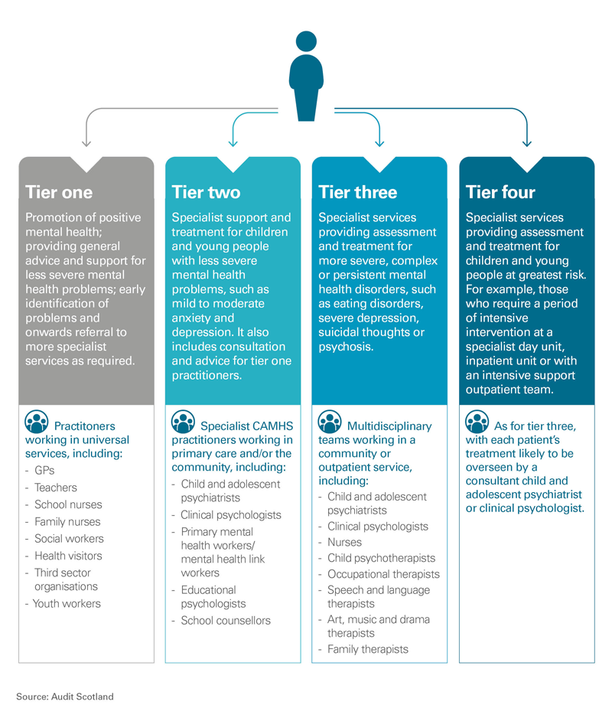

How this works at Cargilfield
All of our teaching staff have received INSET training in aspects of child mental health. Recently this had included developing resilience, and dealing with anxiety. We cover these issues as part of a rolling INSET programme. In addition, we now have an increasing number of staff who hold an NHS qualification in Children and Young Person’s Mental Health First Aid. They are described as Signposters or Mental Health First Aiders. Some of our staff have also done additional training as part of their own professional development in areas such as identifying and working with children with eating disorders or children with behavioural issues.
Your initial point of contact, should you have any concerns about an aspect of your child’s mental health or the school policy, should be your child’s Form Teacher. They may be able to resolve the issue fairly quickly. If they feel that they need assistance in resolving the issue they will speak to a Signposter or if necessary directly with the Headmaster.
We have developed a more in-depth PSHE programme for Form 8. As some parents will be aware this operates on Wednesday evenings in a slightly less formal environment ( home clothes are encouraged and hot chocolate is served) and children are encouraged to debate, ask questions and reflect on some relatively hard hitting issues. We continue to develop this programme and we aim to make it responsive to need. By way of example, this year has seen us discuss: the dangers of alcohol, illegal drug use, cyber bullying, homophobia, sexting, the potential dangers of internet use, resilience, exam stress and relaxation techniques.
Louise MacGregor is our school nurse and she works closely with our staff delivering PSHE to provide advice and develop resources.
We have a school counsellor who can support children on a whole range of issues.
The Governing Board have created an Education and Welfare Committee which oversees (amongst other things) the provision of mental health support in the school. This is made up of a number of experienced educational and medical professionals, the Headmaster and members of our SMT.
In line with Scottish Government guidance we have appointed an Independent Listener who is available to listen to a child’s worries or concerns. She is Morwenna Wood. Morwenna is a former parent and one of our Governors. She is also a medical professional. Her contact details are displayed in every form room in the Upper School. We feel that younger children in the Pre Prep will find it hard to raise issues beyond their Form Teacher. Therefore, as is the case across the School, a wide range of other adults continue to keep an eye on their welfare.
First Steps
Often the first indication that something is wrong will come when a child talks to a member of staff that they trust or a form teacher picks up on something happening in their form. Sometimes a parent or carer may approach a form teacher with a question or a request for help.
Our staff are encouraged to use the matrix at the end of this document to guide them in the provision of appropriate support.
Next Steps
It may be that the Headmaster in consultation with the School Nurse and signposting staff consider it necessary to seek support for the child from another agency. Reference to the tiered diagram of support (above) gives you an idea of who these might be. Typically, we will seek advice from GPs, Social Workers and professionals such as our School Counsellor after consulting parents. It might be necessary for us (as part of our legal duty of care) to seek support from CAHMS or other professionals without initial parental knowledge although they will be consulted as soon as possible.
What do these Professionals do?
It can sometimes be difficult to understand exactly what the role or potential role of each of these professionals might be when dealing with children’s mental health. Although the following is not meant to be definitive, it might help in promoting an understanding of the positive part each of these professionals can play in supporting our children’s mental health.
- School Counsellor- our School Counsellor works in school one day a week. They work closely with individual children to help them develop self-awareness and support their emotional, behavioural, mental and social health and wellbeing. They also work with our SMT and signposting staff to provide support for children and staff on issues affecting the school community. They will speak to a parent or carer before they begin counselling a child.

- GPs- GPs are often the first point of call for a worried parent. We may also advise you to consult a GP for your child. They are physicians who do not specialise in one particular area of medicine. GPs provide routine health care (e.g. physical examinations, immunizations) and assess and treat many different conditions, including illnesses and injuries. They are able to refer children to CAMHS.

- Third sector organisations- sometimes there are third party organisations involved in supporting our children. For example, a number of our children have received support from Richmond’s Hope which provides support for children and young people aged 4-18 years who have been bereaved. Being experts in their field, these organisations have also provided support, advice and useful resources for us to use in our PSHE programmes.

CAMHS- This stands for Child and Adolescent Mental Health Services and is the term for all services that work with children and young people who have difficulties with their emotional or behavioural wellbeing. Access to CAMHS usually comes via a GP referral although in some circumstances other bodies such as a school may refer directly to them. For non-emergencies the waiting time can be fairly lengthy. At the moment it is about 11 to 18 weeks. This often means that parents seek other routes to help their children for example in the private sector. The CAMHS umbrella attempts to provide a framework of multidisciplinary teams that can be targeted to provide appropriate support. The teams can consist of professionals with the following roles:
Psychiatrists
Psychologists
Social Workers
Nurses
Support Workers
Occupational Therapists
Psychological Therapists – this may include child psychotherapists, family psychotherapists, play therapists and creative art therapists
Primary mental health link workers
Specialist substance misuse workers

- Child psychiatrists- Child psychiatrists are medical doctors. This is a speciality within psychiatry. These doctors work with children, young people (up to the age of 18) and their families. They treat (medically and with appropriate therapy) a range of mental health problems and conditions including autism spectrum disorders, depression, anxiety, substance misuse and eating disorders. In some cases our children will see both a child psychiatrist and a child psychologist.

- Child psychologists (and other psychologists) - Child Psychologists help children and young people with a range of mental and behavioural problems – including everything from depression and anxiety, to phobias, trauma, and aggression. Child Psychologists are not (usually) medical doctors. They often have degrees in relevant fields such as nursing, social work or education. They must also work towards a master’s or PhD, before they can specialise in areas such as educational psychology, counselling or clinical psychology. Their job is to observe and analyse patients’ behaviour in age-appropriate situations (e.g. playtime activities with children, or supportive discussions with teenagers) – in order to understand their feelings, determine the route of the problem, and provide support and treatment.
Although they often see patients individually, Child Psychologists could also carry out sessions in a group – with parents or other family members.
- Therapists (including occupational, speech and language, art and music, family) - their roles can be wide-ranging in a mental health context. To give you an idea an occupational therapist operating in this field aims to improve health and wellbeing through enabling participation in occupation (the activities, roles and routines of everyday life). Occupational therapists are a core part of the multi-disciplinary team within CAHMS.

