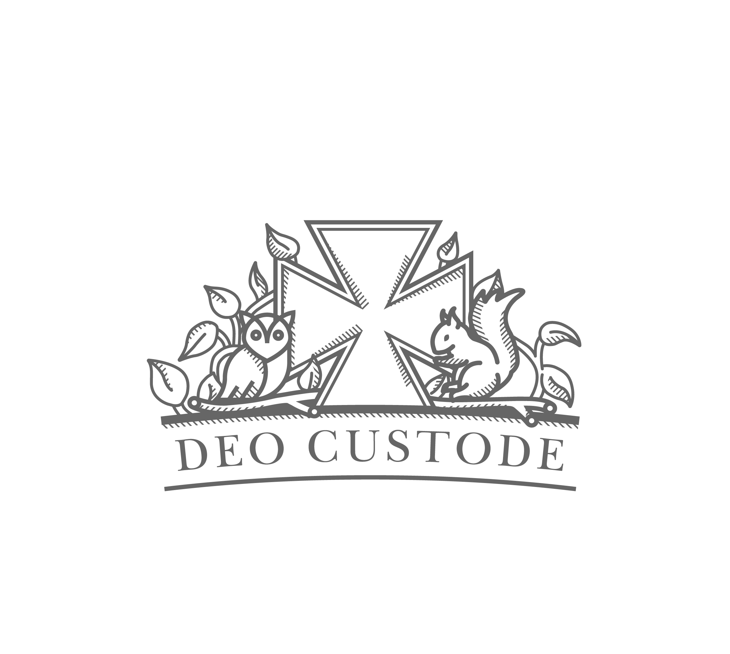

Cargilfield Nursery Healthy Eating Policy
Cargilfied Nursery understands the importance of good nutrition in the early years and that a varied and nutritious diet will support healthy growth and development throughout a child’s life. Good nutrition is vital and children’s experiences of food plays an important part in shaping later eating habits.
Menu
Chartwells catering company provide lunches for all Nursery children. Their menus take consideration of healthy food options that are low in sugar and salt and include plenty of fruits and vegetables. Chartwells use Health Scotland’s ‘Setting the Table- Nutritional guidance and food standards’ as reference.
All menus and snack options are clearly on display in the Nursery cloakroom. The lunch menu is also available to download from the school website, allowing parents to plan different dinners in the evening time.
Lunchtime & Snack time
Children sit down together to eat and drink as this provides an excellent opportunity for them to learn good social skills and behaviours associated with eating and drinking. Chatting to other children and staff, developing good table manners, as well as learning to respect others by tasting and trying foods form different cultures is continuously encouraged in Nursery. Children will also learn to practise personal hygiene skills by washing their hands before eating and drinking.
Children will be provided with plenty of time during snack and lunchtime to promote this. Staff will also encourage children to be independent in using their own cutlery and selecting their own snack. Parents will be informed if their child has not eaten a sufficient amount of food that day or if they haven’t enjoyed a particular type of food.
Snack time is available in the morning and then again in the afternoon to provide children with a chance to eat and drink in between play. Children need to eat regularly and it is recommended that they be offered something to eat at least every 3 hours.
Milk and water are offered during snack times and water is available during lunchtimes and is readily available at all times in Nursery.
The snack menu is changed on a regular basis (at least each term). Children’s ideas are taken into account and ‘Setting the Table- Nutritional guidance and food standards’ is always used as reference.
Staff will encourage the children to eat but will never put any excess pressure on them to do so. Children who do not eat will be offered an acceptable alternative. If this is a continuing problem, then regular contact with parents and carers will be made to discuss this further. Fruit will always be offered even if children refuse to eat their main meal.

Dietary Requirements
Children with specific dietary requirements and allergies will always be offered suitable meals and snacks. Parents of children who are on specific diet will be asked to provide as much written information as possible about allergies and suitable foods (medical form), and in some cases may be asked to provide the foods themselves.
All Nursery and kitchen staff will be aware of any dietary requirements. An allergy and medical conditions document is submitted to all staff at the beginning of each term and all dietary requirements will be displayed in the Nursery kitchen alongside a photograph of the specific child. Nursery staff who serve a child’s food will check potential allergens with the kitchen staff (and allergy folder) and ensure that a child receives the correct food for their diet.
Baking
Children will have regular opportunities to prepare food for snacks and for taking home. They will experience foods from other cultures as part of the curriculum, which involves festivals and celebrations from other countries and religions. Baking activities also follow healthy eating guidelines.
Hygiene procedures
All Children will wash their hands using soap before eating. After lunch all children will wash their hands and faces.
All staff have a food hygiene qualification and will ensure a high standard of hygiene at all times, especially within food areas around the Nursery. Any cutlery or dishes dropped on the floor will be replaced. Please also see our separate hygiene policy.
Home school links
The Nursery requires all parents to work in partnership with the staff in promoting healthy eating for the children and believe that parents and carers play a vital role in supporting children at home what is learned at Nursery.
The Nursery is strictly nut free. No bought or home baking is allowed to be given to Nursery children by staff.
To celebrate a child’s birthday small packets of sweets or chocolate (nut free) may be brought in and shared. These will always be placed into a child’s box, giving onus to parents.
March 2018
Victoria Aitchison

