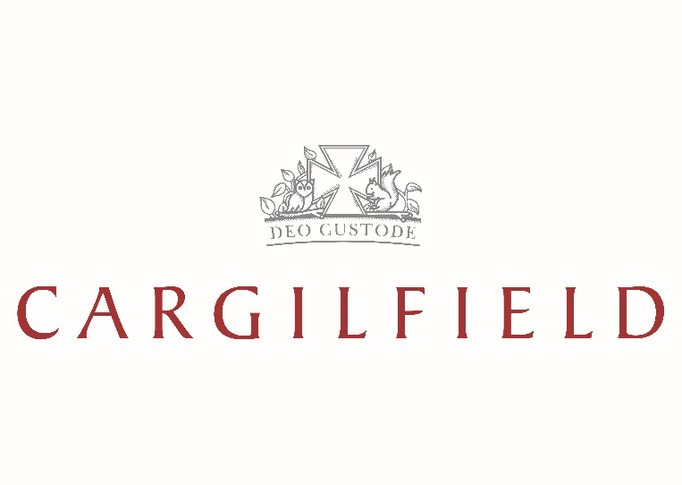

CONFIDENTIAL STATEMENT OF FINANCIAL CIRCUMSTANCES

TO SUPPORT A BURSARY APPLICATION – 2022/23

Please read the guidance notes on pages 8 and 9 before completing this questionnaire.

1. PUPIL (S)

- Full Name (s)

- Date of Birth

2. PARENT DETAILS FATHER / STEP-FATHER MOTHER / STEP-MOTHER

- Name (s)

- Title

- Address

- Postcode

- Telephone No.

- Mobile No.

- Email Address

- OCCUPATION DETAILS

- Occupation

- Employer

- Address

- Postcode

- Telephone No.

- Are you the proprietor, director or shareholder of this company or business?

YES / NO YES / NO

- If ‘Yes’ please state the proportion you own

1

- ANNUAL INCOME

- Gross Salary (to 5th April 2022)

- Taxable Profits (of business)

- Gross Pension (receivable)

- Gross Investment Income

  - Building Society / Bank

  - Dividends

- Gross Rental Income

- Social Security Benefits

- Separation / Maintenance Allowance

- Is there a Court Order / Separation Agreement?

If ‘YES’ please state the annual amount payable for school fees.

- Any other Income?
(please provide details on page 6)

FATHER / STEP-FATHER

YES / NO

MOTHER / STEP-
MOTHER

YES / NO

5. | ANNUAL OUTGOINGS | FATHER / STEP-FATHER
A. | Income Tax
B. | National Insurance Contributions
C. | Pension Contributions
D. | Mortgage Repayments
E. | Annual Rent (on main residence)
 | VERIFICATION OF INCOME | FATHER / STEP-FATHER
 | P60 and P11D (2020/21) | YES / NO
 | Payslip – January 2022 | YES / NO
 | HMRC Self-Assessment Tax Return (2020/21) | YES / NO
 | Confirmation of Schedule D Self- | YES / NO
 | Employment Income
 | Annual Report & Full Accounts | YES / NO
 | Court Order / Separation Agreement | YES / NO
 | Other | YES / NO

MOTHER / STEP-
MOTHER

MOTHER / STEP-

MOTHER

YES / NO

YES / NO

YES / NO

YES / NO

YES / NO

YES / NO

YES / NO

2

6. CAPITAL ASSETS FATHER / STEP-FATHER

- Market Value of Investments

  - Building Society / Bank Deposits
  - Investments (stocks & shares)
  - ISAs etc.
- Market Value of Home

- Market value of Possessions
(including house contents, car etc.)

- Cash & Current A/c
- Net Worth of any Business which you
own or share

- Market Value of other Property, Land
or Buildings

- Other Assets
(please provide details on page 6)

7. CAPITAL LIABILITIES FATHER / STEP-FATHER

- Mortgage

  - Amount outstanding
  - Term remaining
Other liabilities
b.
(please provide details on page 6)

VERIFICATION OF ASSETS | FATHER / STEP-FATHER
Property Valuation | YES / NO
Mortgage Statement | YES / NO
Investment Portfolio Valuation | YES / NO
Contents Insurance Schedule | YES / NO
Car Insurance Schedule | YES / NO
Current & Deposit A/c Statements | YES / NO
Other | YES / NO

MOTHER / STEP-
MOTHER

MOTHER / STEP-
MOTHER

MOTHER / STEP-
MOTHER

YES / NO

YES / NO

YES / NO

YES / NO

YES / NO

YES / NO

YES / NO

3

8. DEPENDENT CHILDREN | 1 | 2 | 3

- Name

- Date of Birth

- School

- Boarding / Day?

- Annual Fees

- Compulsory Extras

- Bursary / Scholarship Armed Forces,
- Diplomatic or Company Education Allowance

- Family Assistance

- Other Assistance

If one of your children listed above will be leaving Cargilfield at the end of academic year 2021/22 to attend a fee-paying senior school, please record the fact in section 10 with details of the expected fees payable and bursaries receivable in 2022/23.

Please list below all Trusts held by Parents, Step Parents, Grandparents, Children and provide a valuation of the Trust:

Please list below all unearned income (of the child), e.g. interest from bank or building society deposits, share dividends etc.

4

- MONTHLY HOUSEHOLD INCOME AND EXPENDITURE

MONTHLY INCOME: MONTHLY EXPENDITURE:

TOTAL EXPENDITURE:

5

10. ADDITIONAL DETAILS

6

- DECLARATION

We have read the notes and have made a complete and accurate declaration of our income and assets.

We understand that if we are offered a Bursary for our child and accept a place for him / her at the
School, the following terms and conditions will apply:

- Our child’s fee account with the School will be credited termly with the amount of the Bursary;

- The Bursary is subject to either termly or annual review, and an annual declaration of our financial circumstances must be completed and all relevant supporting evidence supplied by the date requested;

- Any material change to our financial position will be reported immediately to the School.

The bursary may be withdrawn or reduced if:

- We breach the Terms and Conditions as set out in the Parent Contract;
- We are more than 28 days in arrears in respect of any amount due and owing to the School;
- We fail to complete the annual declaration of financial circumstances by the date requested;
- We fail to produce relevant supporting evidence of our financial position;
- There is a material change in our financial circumstances;

- In the opinion of the Headmaster, our child’s attendance, progress or behaviour no longer merits the continuation of the award;

- The School’s resources are insufficient to maintain the level of award.

THE BURSARY WILL BE WITHDRAWN AND THE AMOUNT OF BURSARY PREVIOUSLY CREDITED AGAINST OUR CHILD’S FEE ACCOUNT WILL BECOME REPAYABLE TO THE SCHOOL IMMEDIATELY IF WE HAVE FRAUDULENTLY, KNOWINGLY OR RECKLESSLY PROVIDED FALSE INFORMATION.

BY SIGNING THIS FORM, WE CONSENT TO CARGILFIELD SCHOOL COMMISSIONING A DIRECTORS SEARCH, PROPERTY SEARCH AND CREDIT REPORT UNDER OUR NAME AND ADDRESS.

SIGNATURE DATE

Mother / Step Mother

Father / Step Father

7

GUIDANCE NOTES

Before completing the form please read these notes carefully and contact the Bursar if further information or advice is required.

All figures should be recorded in £ Sterling, and with the exception of the Monthly Household Income and Expenditure statement, should be recorded as ANNUAL figures.

- PARENT DETAILS

Parent is defined as:

  - the natural father and mother of the child, where they live together and the child resides with them both;

  - the parent of the child with whom the child normally resides, and the partner of that parent where they live together;

  - the child’s guardian appointed in accordance with the Children (Scotland) Act 1995, and the partner of that guardian where they live together;

  - the person with whom the child resides in accordance with either:
    - a subsisting residence order under the Children (Scotland) Act 1995;

    - any subsisting court order (other than a residence order) which specifies who is to have actual custody or care and control of the child;
    - any informal care or fostering arrangement.

  - Parents who are separated or divorced, are required to complete individual application forms;

  - Where a child either has no parents as defined above and is either looked after by a local authority or provided with accommodation within the meaning of the Children (Scotland) Act 1995, the child shall be treated as one whose parents have no income for the purpose of this application.

- INCOME

- GROSS annual salary and wages, including any part-time employment, bonus, commission,

redundancy, termination etc., statutory sick pay, and statutory maternity pay for the current financial year ending 5th April 2022.

- GROSS income agreed by HMRC allowances, losses and stock relief).

(deductions should be made only in respect of capital A copy of the full accounts and annual report is required.

- All other Investment Income (e.g. interest, dividends, annuities etc.) should be recorded GROSS of tax. If tax was deducted at source, applicants should add back the amount of tax paid or tax credit notified.

- All receipts relating to separation and maintenance payments, must be declared.

8

- Where a parent is required by a Court Order, or a separation agreement to pay part of the School fees, then only the element of the fee which is not covered by the Court Order or agreement will be used for the purposes of this application, irrespective of whether it is being complied with. Where the whole amount of the fees is required to be paid by virtue of a Court Order or agreement, applicants are not eligible for a bursary. A copy of the court order or separation agreement is required.

- CAPITAL ASSETS

- Capital sum of any monies on deposit with a bank or building society. Market value (as is reasonably practicable) of stocks and shares.

- Market value of your home (please provide an estimate if a current valuation is unavailable).

- Net worth of any business owned or shared. Shares (in a company not listed on a stock exchange) should be valued as a proportion of the net value of the company.

- Market value of second homes and/or other properties, land or buildings (please provide an estimate if a current valuation is unavailable); no allowance will be made for any outstanding mortgage.

- DEPENDENT CHILDREN

Column 1 should be for the child for whom you are applying, and columns 2 and 3 for any other children who are in full time education.

- Current academic year (2021/22).

- Only include compulsory extras for which you are not entitled to ‘opt out’.

Where a Trust has been established in favour of the child for whom you are applying, details of the annual amount available and the date of commencement of payment from the Trust should be given.

Where the child has any unearned income, e.g. interest from National Savings, bank or building society deposits, or receives share dividends, please provide details of the source of income and the gross amount received before deduction of tax.

- ADDITIONAL DETAILS

Please enter, on a separate sheet if necessary, any details which may affect the assessment of a bursary e.g. a significant change in income or outgoings for the coming year.

9

