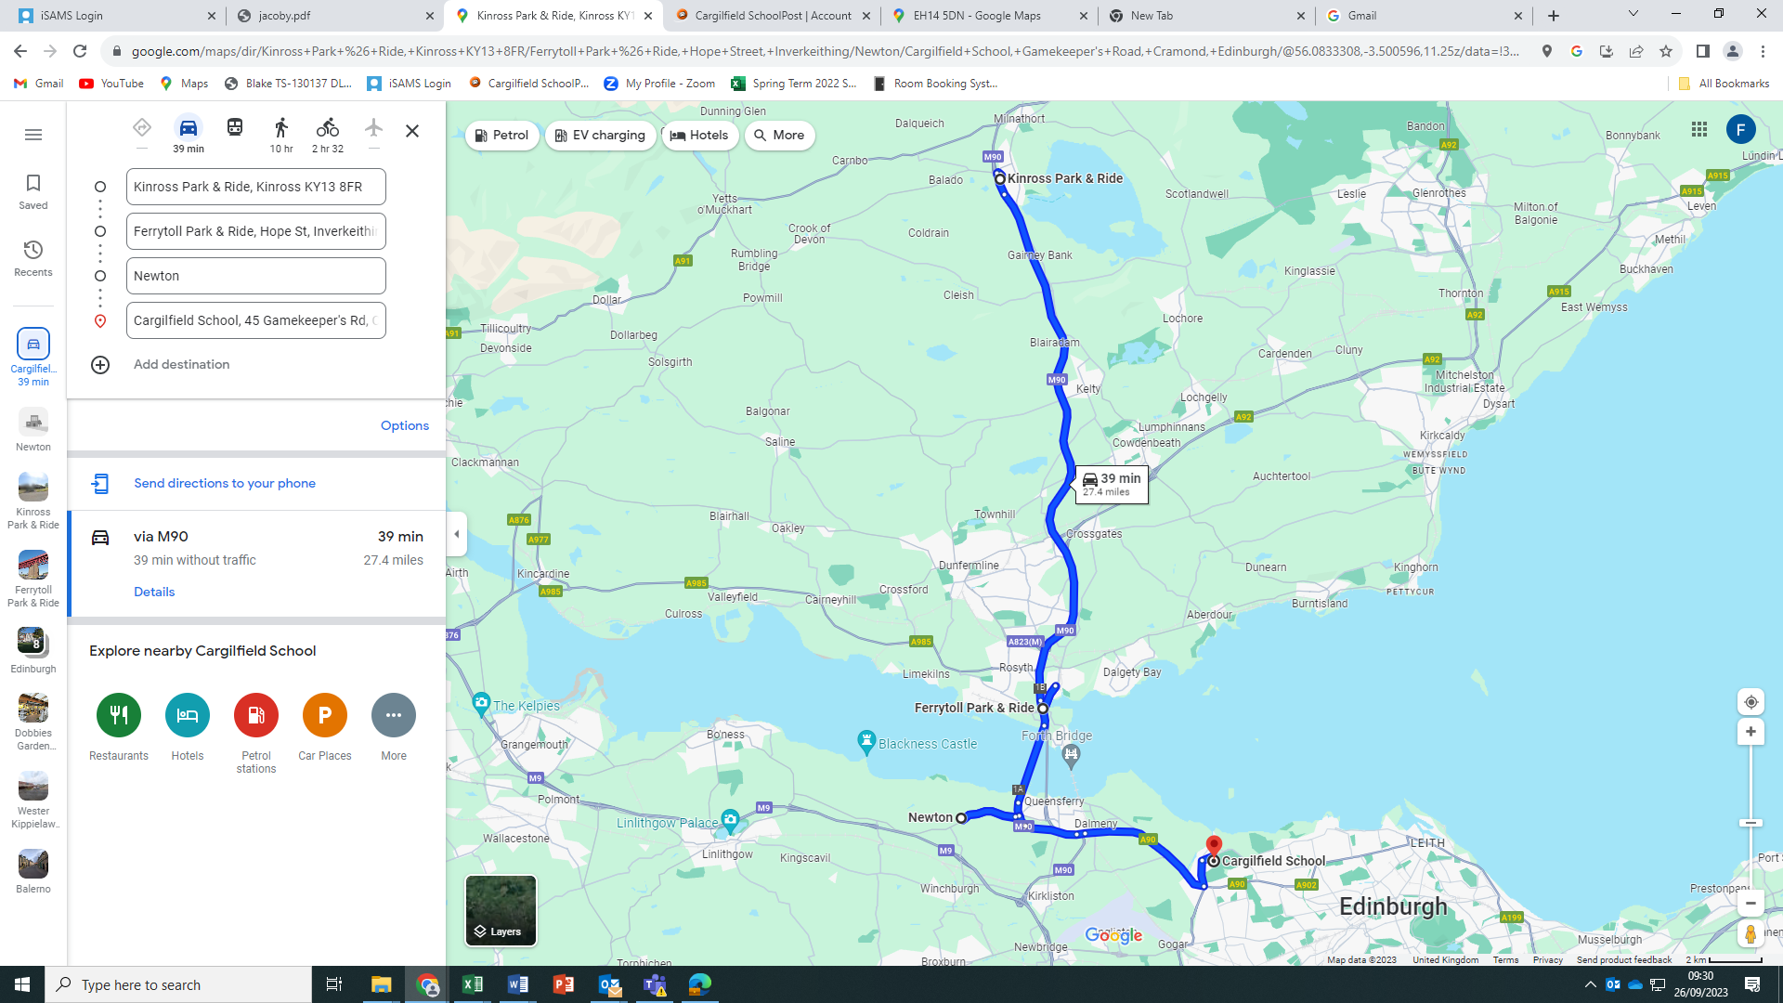

**BUS 1**

**Kinross Park and Ride (Junction 6 on M90) leaving at 7.25am**

**Fife (Inverkeithing Park and Ride) leaving at 7. 45am**

**Newton (Jet Garage) leaving at 7.55am**