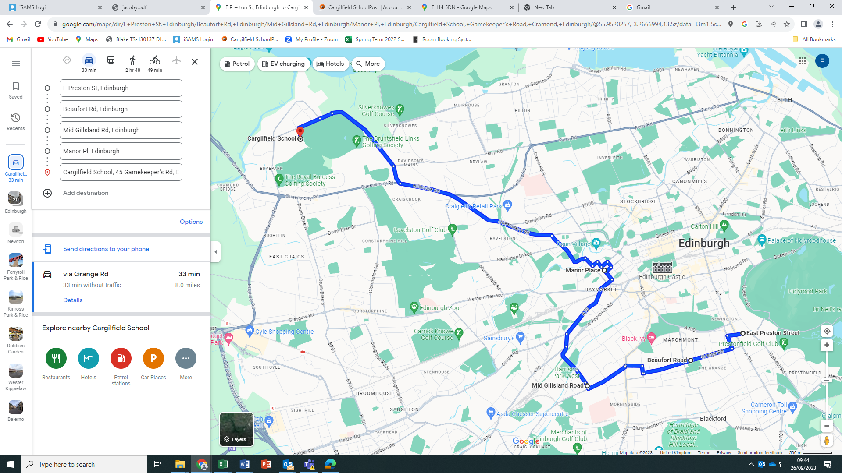

**BUS 2**

East Preston Street (Cemetery entrance) at 7.30am

Beaufort Road (entrance to the Grange Cemetery) leaving at 7.40am

Spylaw Road/Mid Gillsland Road leaving at 7.50am

**Manor Place (outside the GP surgery) leaving at 8.00am**

**Keith Row, Blackhall leaving at 8.10am**