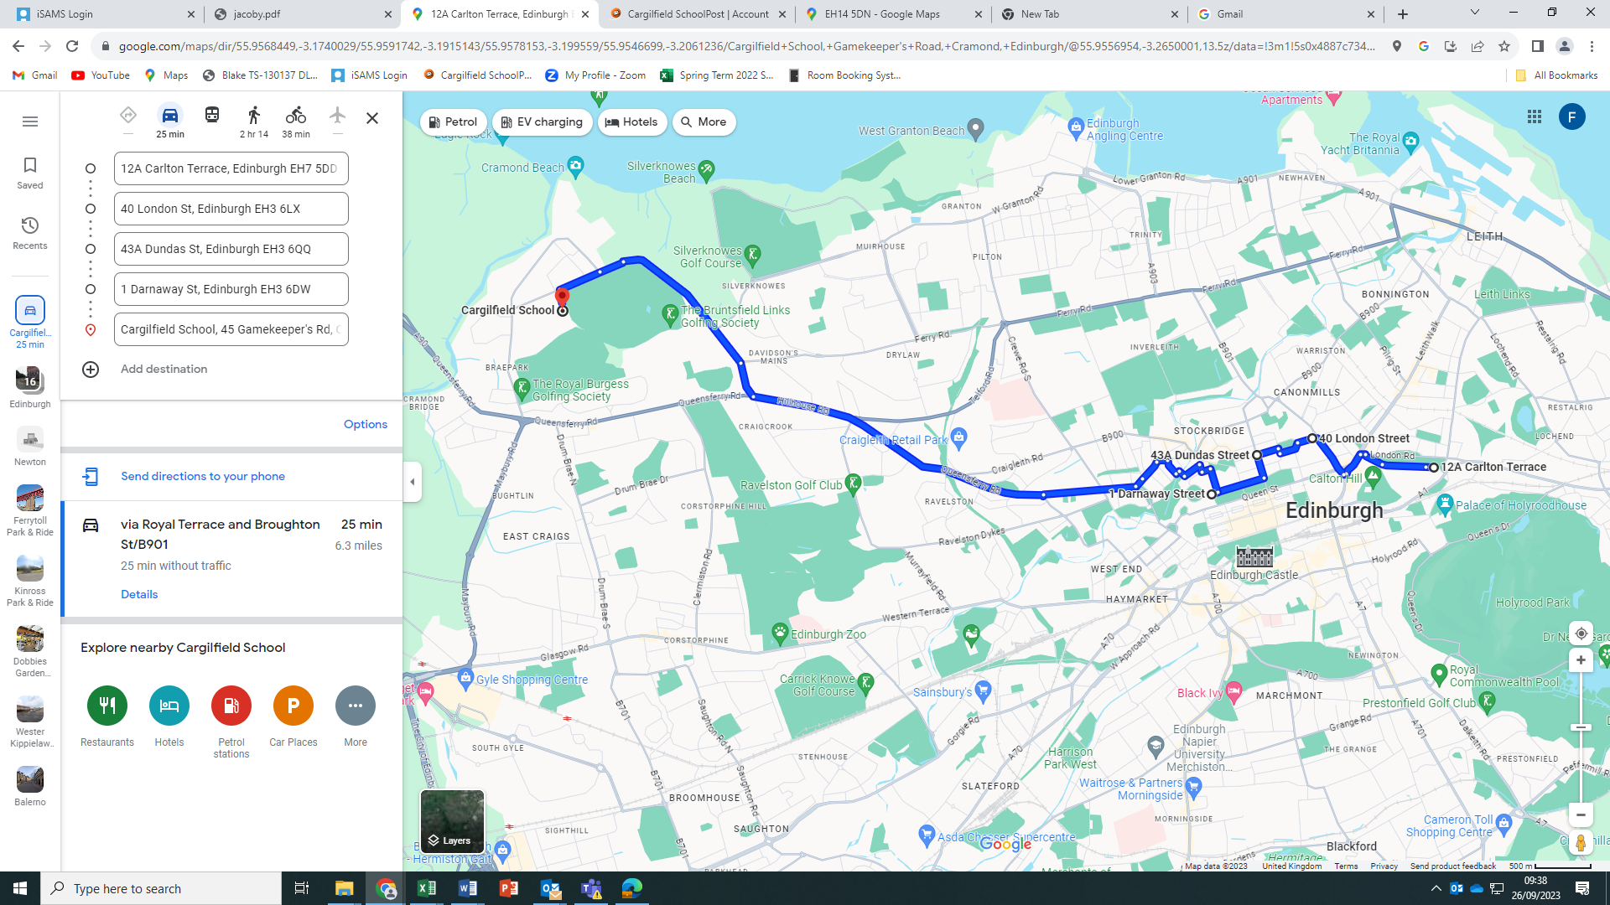

**BUS 3**

**Royal Terrace (Carlton Terrace end) leaving at 7.40am**

**London Street (Broughton Street End) leaving at 7.45am**

**Dundas Street (Great King Street Junction) leaving at 7.50am**

**Wemyss Place (Heriot Row end) leaving at 8.00am**