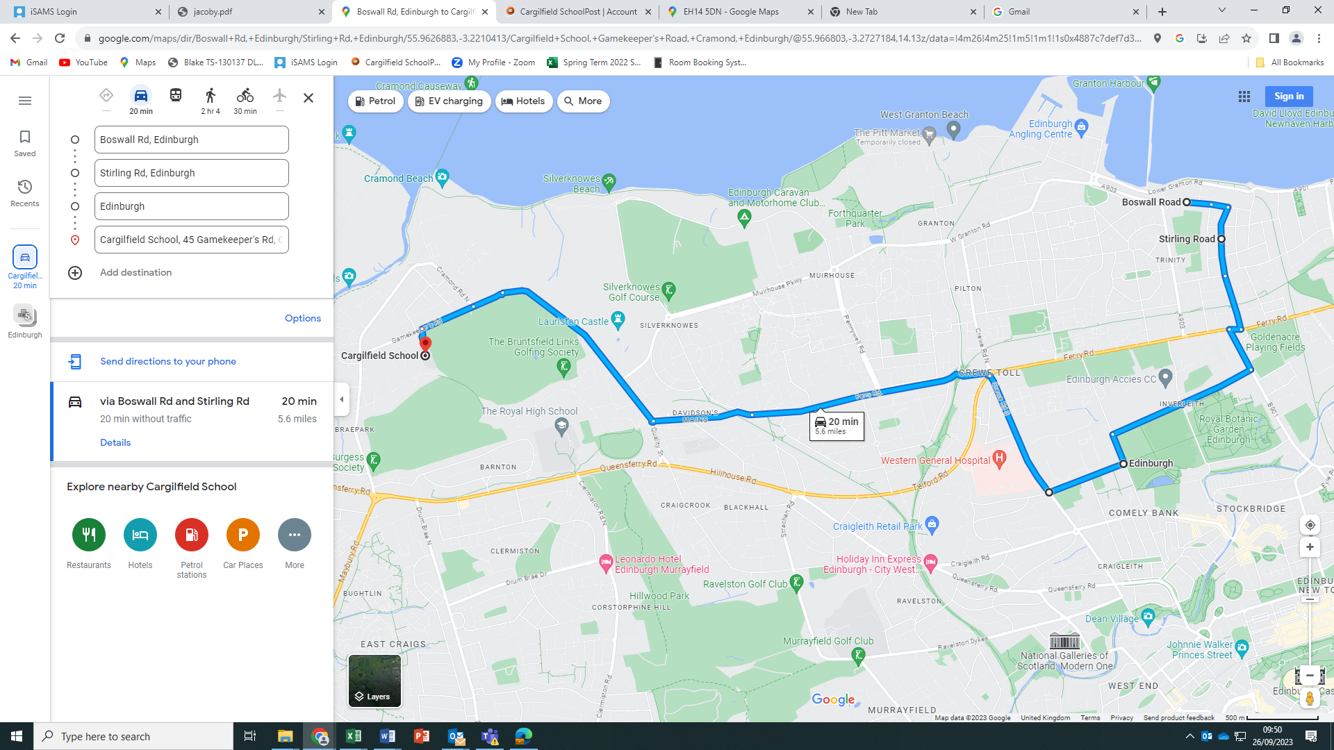

**BUS 4**

**Boswall Road (outside no 3) leaving at 7.40am**

**Stirling Road (by the tennis courts) leaving at 7.45**

**East Fettes Avenue (by Carrington Road), leaving at 7.55am**