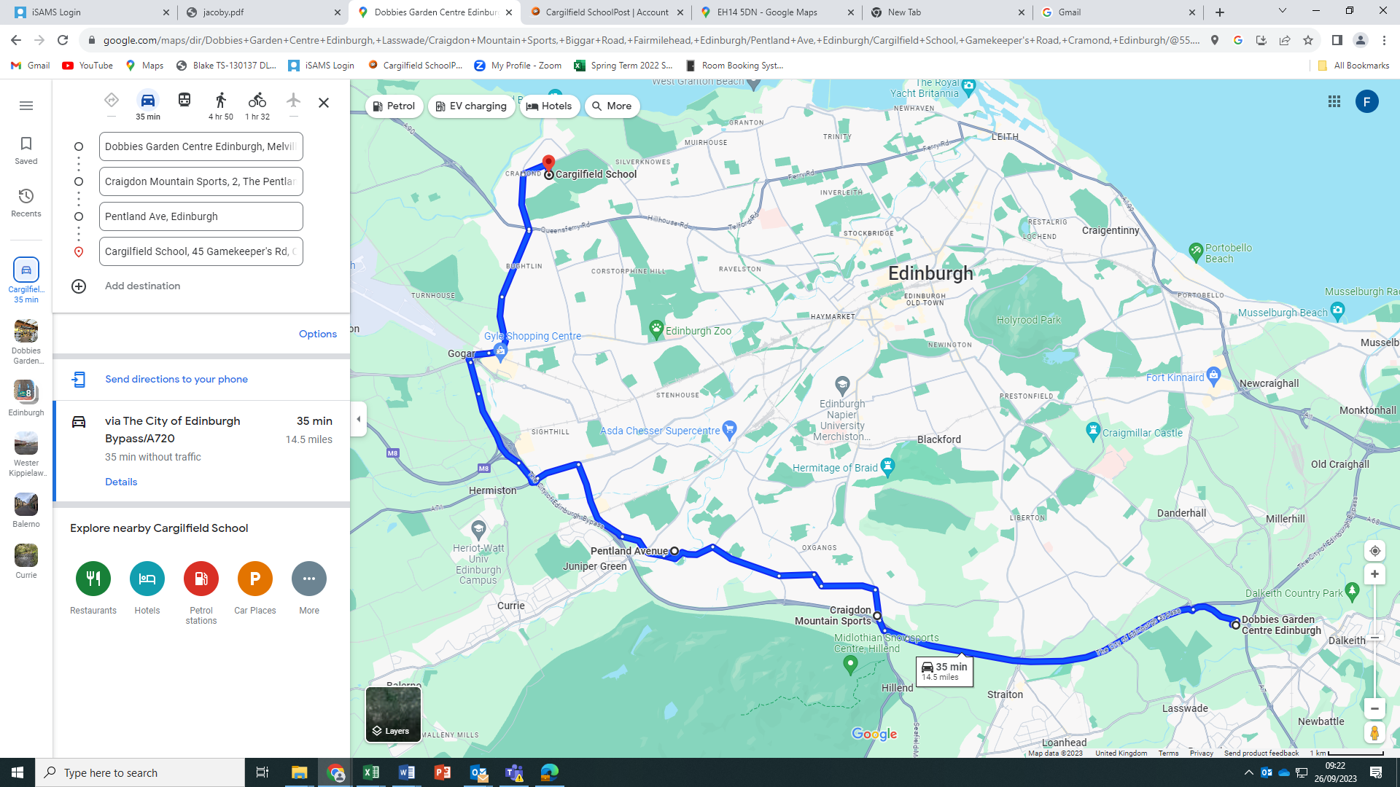

**BUS 5**

Dobbies Garden Centre, Lasswade, leaving at 7.30am

Craigdon Mountain Sports car park, leaving at 7.40am

Pentland Avenue, Colinton, leaving at 7.55am