Form 8 Revision
John Churchill 1st Duke of Marlborough
(A possible CE evidence question for 2019/20)

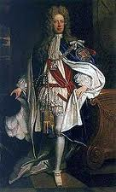

Introduction
John Churchill, 1st Duke of Marlborough was an English soldier and statesman whose career spanned the reigns of five monarchs.
Churchill’s father had fought for the Royalists during the Civil War which left the family penniless after the parliamentarian victory, although the family’s fortunes were somewhat restored after the Restoration in 1660.
Churchill was educated at the Dublin Free School and St Paul’s school in London. His career began as a page to James Duke of York he served James, Duke of York, through the 1670s and early 1680s, earning military and political advancement through his courage and diplomatic skill. Churchill's role in defeating the Monmouth Rebellion in 1685 helped secure James on the throne. Churchill was promoted to Major General and successfully led the troops that defeated Monmouth at Sedgemoor on July 6th1685. After the rebellion Churchill began to move himself away from James II’s increasingly Catholic regime and three years later he abandoned his Catholic patron for the Protestant Dutchman, William of Orange.
Honored for his services at William's coronation with the earldom of Marlborough, he served with further distinction in the early years of the Nine Years' War but saw only three years of active service. Following several fraudulent plots that implicated Marlborough against the King he was imprisoned in the Tower of London.
Churchill married his wife Sarah Jennings in 1675. She was a friend of Princess (later Queen) Anne and served as one of her ladies in waiting. With the accession of Queen Anne in 1702 Marlborough was knighted, named Captain General of the Armies, and Master General of the Ordinance and later in 1702 was raised to Duke.

The Spanish Wars of Succession
In 1699 Charles II the King of Spain had died without an heir and left his throne to Philip of Anjou the grandson of Louis XIV the King of France. Louis now claimed Spain (despite a promise to Charles II that he would not unite the two countries) and also threatened the Netherlands and Austria.
England declared war on France and persuaded other countries (Austria, Prussia, Demark and Holland) to join her in a Grand Alliance. The Principle aim was to prevent the creation of a united France and Spain.
In 1703-04 the French moved in Germany and Italy where they inflicted a heavy defeat on the Austrians and then threatened to take Vienna.
Marlborough was determined to assist Austria and marched his army 300 miles in 5 weeks across Europe to join up with Prince Eugene of Savoy. The combined army amounted to 56,000 men.
The allied forces met a French and Bavarian army commanded by Marshal Tallard at Blenheim on 13th August 1704.
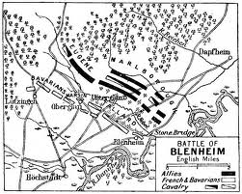
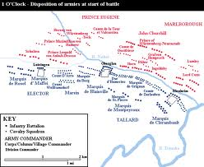

The Battle
The two armies lined up on either side of a marshy stream called the Nebel.
Marlborough was confident that he had the stronger cavalry but overall his force as heavily outnumbered by the by the Franco-Bavarian force.
Tallard had arranged his cavalry in the center with infantry on both flanks. Marlborough’s plan was to attack both flanks at once and trick the French into sending troops to reinforce them. This would mean that the French cavalry in the center was weakened and would give Marlborough the opportunity to attack. This would only work if all Marlborough’s commanders understood their missions and worked together.
Lord Cutts and Eugene of Savoy two of Marlborough’s commander’s attacked on the flanks. Cutts attacked Blenheim and Eugene of Savoy attacked Lutzingen. After some fierce fighting some of the French in the center were sent to provide support to their troops in these villages. (Just what Marlborough had hoped would happen)
Marlborough and his brother, Churchill marched their horses and infantry across the Nebel towards the center of the French formation. The Allied infantry used a combination of constant running fire, cannon fire and a cavalry charges which inflicted heavy losses on the French.
Despite Tallard’s best efforts the French cavalry broke and ran. By 7pm the French army had been virtually destroyed with at least 40,000 killed, drowned in the Danube trying to escape or taken prisoner. The Allies lost about 6,000 men with about 8000 wounded.

The Consequences
- The Duke of Marlborough had completely changed the course of the war of Spanish Succession.
- The French were now on the defensive and no longer the dominant military power in Europe and fighting to defend their boarders.
- Vienna was saved and the Grand Alliance preserved.
- France agreed to recognise Anne as the rightful Queen of England and drop its support of James Edward Stuart
- France conceded territories to England in the New World
- The unification of France and Spain was prevented
- Marlborough who had never commanded a major army in battle before became a national hero

