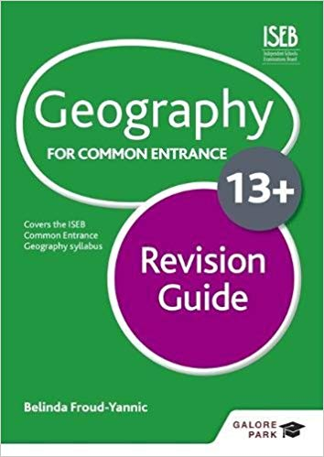
F8 CE Geography November 2020

I recommend the ISEB Geography Revision Guide:

Exam

The 7 children who studied with me last year will get a full CE paper. Use case studies from last year.

The others will only be tested on the following sections:

- OS maps
- Global location
- Plate Tectonics
- Structure of the earth
- Oceanic / continental crust
- Tectonic plates and boundaries including diagrams
- Global distribution of earthquakes and volcanoes
- Case studies: Mount Merapi 2010, Japan Earthquake/ Tsunami 2011

- Weather and climate
- Difference between weather and climate
- Microclimates
- The water cycle
- Types of rainfall: relief, frontal and convection including diagrams
- Causes of temperature and rainfall variation from place to place in British Isles

- Rivers and coasts
- Processes of weathering, erosion and transportation
- Landforms and diagrams showing their formation:
    - Valley
    - Waterfall
    - Gorge
    - Meander
    - Caves, arches, stacks, stumps
    - Beaches
    - Spits

