Term overview for 7P – Autumn 2022

Subject | Topic Areas Covered | Key texts/Resources Used
Maths | Number and numeracy: The four operations for decimals and fractions; ratio, scale and proportion.  Algebra: Substitution, expanding brackets, factorising and simplification.  Space and shape: Circles: calculating the area and circumference of circles and part circles.  Investigations and puzzle work. | Revision notes  Past paper questions and exercises  Text Book “So you really want to learn Maths – book 2” S. Alexander (ISEB)  BBC Bite size Key Stage 3  Mymaths
RS | Islam (Common Entrance Syllabus)  - Islamic Beliefs  - Prophets  - Holy Books  - Life after Death | Resources by IP  The Muslim Experience by Aylett & o’Donnell
Geography | - Weathering and Erosion  - Features of river valley  - The lower course of the river  - Coastal processes of erosion and deposition  - Coastal features  - Protecting the coastline  - Flooding case study | - ISEB Geography for Common entrance  - Key Geography  - Geog.GCSE book  - So you really want to learn Geography
History | - Who were the Tudors?  - Henry VII- what kind of monarch was he?  - The Pretenders  - The Church in early Tudor times  - Henry VIII and his wives  - Thomas Wolsey  - The Break from Rome | - ISEB revision notes  - Past papers and practice exercises  - History on the Net  - The Making of the UK  - In Search of History  - ISEB History for CE  (Please note that the ISEB have published a new specification for History from Sept 2021. There is a new version of the Revision Guide.
French | - Revision of basics (describing yourself and others, weather, present tense)  - Going on a trip: saying where you are going, inviting someone, ordering food and drinks. Using the Near future tense and the modal verb vouloir.  - Describing where you live. Talking about what you do to help at home (chores…)  - Daily routine: reflexive verbs, telling the time, modal verbs (revision).  - After half term and exams: describing past holidays using the past tense.  Regular exam practice and learning exam techniques (Listening, Reading and Writing) | Dynamo 1 Module 5  Dynamo 2 Module 1  Activelearn website  Language gym  Past papers  Power points
Science | - Maths skills for scientists  - Cells/organisation (biology)  - Electric circuits (physics)  - Respiration/gas exchange system (biology)  - Revision of key topic areas for examinations | - ISEB revision guide (13+)  - Memory workout booklet  - Revision notes  - Past paper questions and exercises  - Text Book “So you really want to learn Science – book 2” W.R. Pickering (ISEB)  - BBC Learning Zone / Science / Secondary (Clips)
Latin | - 1st and 2nd Declension Nouns  - 1st – 4th Conjugation Verbs  - Imperfect and Perfect Tenses  - Sum | - Oulton, ‘Latin One, for Common Entrance.’  - Past papers.
Art | MUSIC AND ART  How can you articulate sound using drawing and painting?  - Folder Designs  - Folder Designs  - Painting to music  - Who was Kandinsky? - Artist Research Page  - Drawing Assessment  - Drawing Assessment  HALF TERM  - Clay – abstract shapes in 3D Forms  - Make a playlist- suggest two pieces of music that have no lyrics – make your own interpretation of this music.  - Can we make these paintings into textiles or prints? Textile making workshop  - Textile project.  - Reflections  - Christmas cards | WASSILY KANDINSKY  https://www.tate.org.uk/kids/make/art-technology/draw-sound-creature  Artist Research  https://www.tate.org.uk/art/artworks/kandinsky-cossacks-n04948/how-paint-kandinsky  'Colour is a power which directly influences the soul.'  (1866–1944)  - Wassily Kandinsky was a Russian painter.  - He was a pioneer of ABSTRACT PAINTING.  - He gave up his career as a Lawyer to paint.  - Kandinsky was obsessed with Monet which led him to explore his own creative concepts of colour on canvas.  - He was inspired by music  - He had Synaesthesia - he literally saw colours when he heard music, and heard music when he painted.  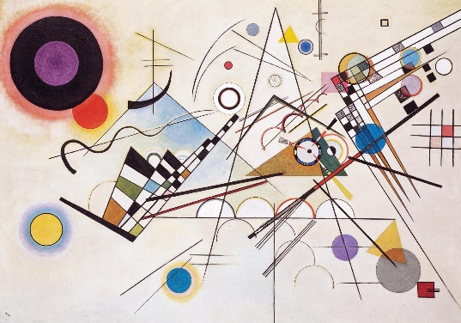Composition VIII, produced in 1923
English | - Creative writing  - Poetry writing  - Prose comprehension  - Poetry comprehension  - Writing to inform, explain or describe.  - Writing to explain, discuss or analyse.  - Exam preparation. | - Set text- Rooftoppers by Katherine Rundell  - SPLAT analysis placemats- (Structure, Purpose, Language, Audience, Text Type).  - Poetry and War Poetry Anthologies  - Dancing by the Light of the Moon- Giles Brandreth.  - CE at 13+ English text book

