7F Autumn Term 2022
Subject Topics
Subject | Topics | Resources
Maths | Number and numeracy: The four operations for decimals and fractions; ratio, scale and proportion.  Algebra: Substitution, expanding brackets, factorising and simplification.  Space and shape: Circles: calculating the area and circumference of circles and part circles.  Investigations and puzzle work. | Revision notes  Past paper questions and exercises  Text Book “So you really want to learn Maths – book 2” S. Alexander (ISEB)  BBC Bite size Key Stage 3  Mymaths
English | Studying Skellig by David Almond and focusing on developing writing skills and strategies in preparation for their forthcoming exams.  They will also be focusing on developing poetry analysis skills with Mr Taylor. | - ISEB English by Susan Elkin book 2 & 3  - Comprehension to 14 by Geoff Barton.  - Poetry anthologies  - Skellig by David Almond
Science | - Maths skills for scientists  - Cells/organisation (biology)  - Electric circuits (physics)  - Respiration/gas exchange system (biology)  - Revision of key topic areas for examinations | - ISEB revision guide (13+)  - Memory workout booklet  - Revision notes  - Past paper questions and exercises  - Text Book “So you really want to learn Science – book 2” W.R. Pickering (ISEB)  - BBC Learning Zone / Science / Secondary (Clips)
French | - Revision of basics (describing yourself and others, weather, present tense)  - Going on a trip: saying where you are going, inviting someone, ordering food and drinks. Using the Near future tense and the modal verb vouloir.  - Describing where you live. Talking about what you do to help at home (chores…)  - Daily routine: reflexive verbs, telling the time, modal verbs (revision).  - After half term and exams: describing past holidays using the past tense.  Regular exam practice and learning exam techniques (Listening, Reading and Writing) | Dynamo 1 Module 5  Dynamo 2 Module 1  Activelearn website  Language gym  Past papers  Power points
Latin | - 3rd Declension Nouns.  - Future Tense.  - Pluperfect Tense.  - 3rd Declension Adjectives.  - Personal Pronouns.  - Comparison of Adjectives. | - Oulton, ‘Latin Two, for Common Entrance.’  - Bass, ‘Practice Exercises Level 2’.  - Past papers.
History | - Who were the Tudors?  - Henry VII - what kind of monarch was he?  - The Pretenders  - The Church in early Tudor times  - Henry VIII and his wives  - Thomas Wolsey  - The Break from Rome | - ISEB revision notes  - Past papers and practice exercises  - History on the Net  - The Making of the UK  - In Search of History  - ISEB History for CE  (Please note that the ISEB have published a new specification for History from Sept 2021. There is a new version of the Revision Guide.
Geography | - Weathering and Erosion  - Features of river valley  - The lower course of the river  - Coastal processes of erosion and deposition  - Coastal features  - Protecting the coastline  - Flooding case study | - ISEB Geography for Common entrance  - Key Geography  - Geography GCSE book  - So you really want to learn Geography
Theology, Philosophy and Religion | Islam (Common Entrance Syllabus)  - Islamic Beliefs  - Prophets  - Holy Books  - Life after Death | Resources by IP  The Muslim Experience by Aylett & O’Donnell
P.S.H.E. | - Vanity  - Positive Mind Set  - Drugs  - Revision Techniques | Please look at the website for a guidance planned topics. Topics are often substituted to relate to specific issues that have arisen. If you have any questions, please feel free to get in touch with me (Isabella Pett at ipett@cargilfield.com)"
Art | MUSIC AND ART  How can you articulate sound using drawing and painting?  - Introduction to drawing to music  - Painting to music  - Painting to music  - Who was Kandinsky? - Artist Research Page  - Drawing Assessment  - Drawing Assessment  HALF TERM  - Clay – abstract shapes in 3D Forms  - Make a playlist - suggest two pieces of music that have no lyrics - make your own interpretation of this music  - Can we make these paintings into textiles or prints? Textile making workshop  - Textile project  - Reflections  - Christmas cards | WASSILY KANDINSKY  https://www.tate.org.uk/kids/make/art-technology/draw-sound-creature  Artist Research  https://www.tate.org.uk/art/artworks/kandinsky-cossacks-n04948/how-paint-kandinsky  'Colour is a power which directly influences the soul.'  (1866–1944)  - Wassily Kandinsky was a Russian painter.  - He was a pioneer of ABSTRACT PAINTING.  - He gave up his career as a Lawyer to paint.  - Kandinsky was obsessed with Monet which led him to explore his own creative concepts of colour on canvas.  - He was inspired by music  - He had Synaesthesia - he literally saw colours when he heard music, and heard music when he painted.  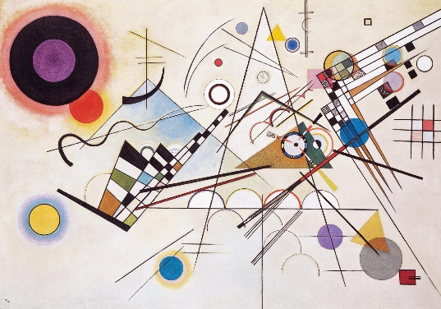Composition VIII, produced in 1923
Design Technology & Computer Science Projects | Woodwork project – pencil box, bookends etc  3D Printing

